Algebra II
7-1 A Graphing Exponential Functions

Graph each function. State the domain and range. Determine if the function represents growth or decay.

1. y = ${3(2)}^{x}$ 2. y = ${4\left(\frac{1}{5}\right)}^{x + 3}$ – 1 3. y = ${0.25(5)}^{x}$
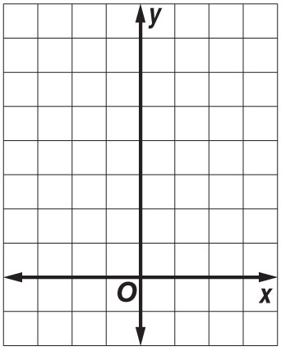
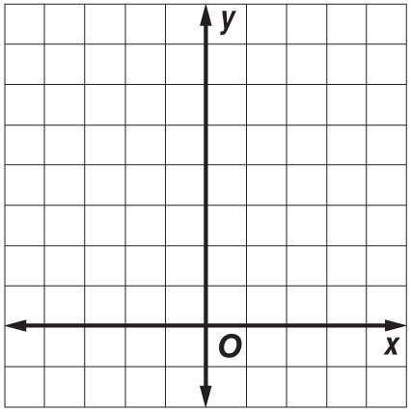

4. y = ${2(3)}^{x}$ 5. y = $4^{x}$ – 2 6. y = 6${\left(\frac{1}{2}\right)}^{x}$
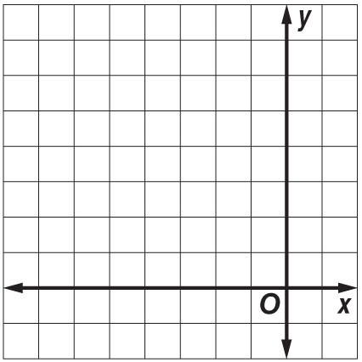
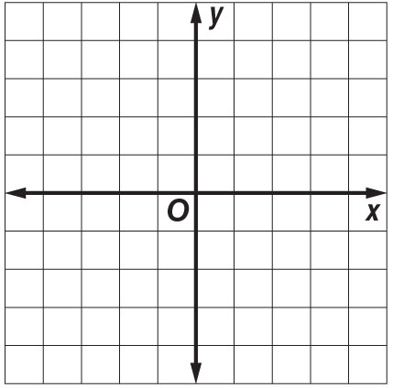
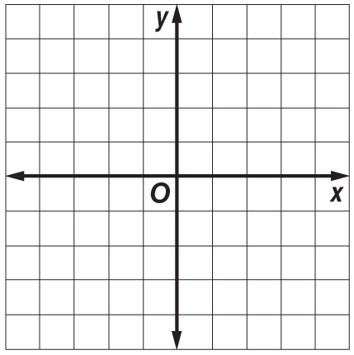

7. y = $2^{x + 5}$ 8. y = –2${\left(\frac{1}{4}\right)}^{x}$ 9. y = –0.4${(0.2)}^{x}$
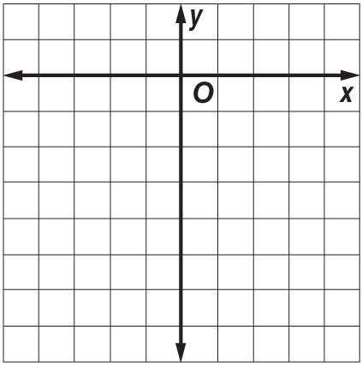
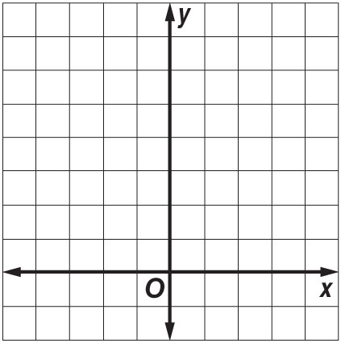
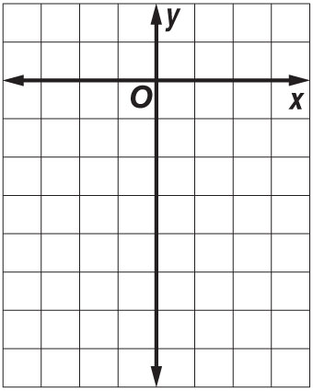

10. y = $\left(\frac{2}{5}\right){\left(\frac{1}{2}\right)}^{x - 1}$ + 2 11. y = ${\left(2\right)}^{x + 3}$ – 1 12. y = $\left(-\frac{1}{3}\right){\left(\frac{3}{4}\right)}^{x - 5}$ + 6
